**Halophytes**

**Definition**

Halophytes are salt-resistant or salt-tolerant plants that thrive and complete their life cycles in soils or waters containing high salt concentrations.

**Problems with high soil salinity**

Movement of water between [soil](http://lifeofplant.blogspot.com/2011/01/soil.html) and plants occurs by osmosis.

Water moves from an area of low solute concentration (low salt concentration) to an area of higher solute [concentration](http://amazingrainbow.blogspot.com/2009/10/your-power-of-real-concentration.html)

A common measure of the tendency of aqueous solutions to “attract” water is called osmotic potential.

The osmotic potential of water with solutes is always expressed as a negative number, and the higher the concentration of solutes, the more negative the osmotic potential.

If large concentrations of soluble salts are present, as in saline or excessively fertilized soils, osmotic potential in the soil becomes more negative than in plants, causing water to move from[**roots**](http://lifeofplant.blogspot.com/2011/01/roots.html)**to soils.**

**Halophyte adaptations**

Resistance of halophytes to salt stress involves two different adaptations: salt tolerance, which involves accumulating salts in the plant’s cells, and salt avoidance, which involves adaptations to minimize the concentrations of salt in the cells or adaptations to bar salts from entering through plant roots. These two adaptations have led to the designations **“salt accumulators”** and **“salt excluders,”** respectively.

**Salt Accumulators**

**Examples = salt bush, smooth cord grass, saltgrass and tamarisk**

**Adaptations**

* Have specialised cells called salt glands located on the surface of their leaves, used for storing excess salt (NaCl)

These glands fill with salt and eventually burst, releasing the salt to form a crystalline layer on leaf surface which falls the ground or is washed off by rain.

* Some salt accumulators avoid salt stress by minimizing salt concentration in the cytosol of their leaf cells. Leaf cells regulate cytosolic salt levels by transporting sodium and chloride ions into the central vacuole.
* A high salt concentration in the vacuole causes it to take up more water and swell. As the water-filled vacuole pushes the cytosol toward the cell membrane and cell wall, the cell maintains its turgidity, typical of succulents such as pickleweed.
* Other halophytes can accumulate and concentrate the salts in their cells up to a certain toxic concentration, at which point the salts cause the plant to die.

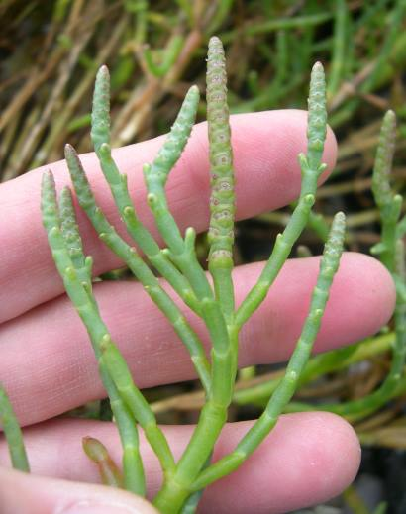 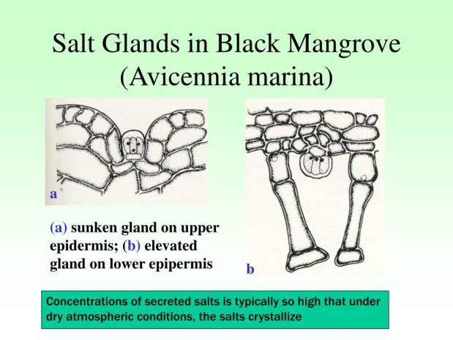 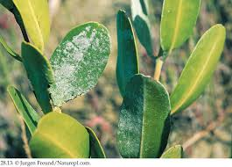

**Salt Excluders**

**Examples = Mangrove species (red, black & white), maize, olive**

**Adaptations**

* Some salt excluders avoid salt stress by defoliation or abscission (leaf release). When salt concentrations in plant cells becomes dangerously high, excess sodium chloride (salt) is moved to petioles (stems that connect leaves to the main stem). The petiole, including the leaf dies and detaches from main stem taking the excess salt with it.
* The root epidermis (outer layer of cells) of some halophytes, block the passage of sodium and chloride ions through the cell membrane. Roots also have an endodermis (inner layer of cells) that contains waxy strips surrounding each cell, to obstruct the entry of sodium and chloride ions.
* In some plants, root cells are capable of **actively pumping** excess sodium and chloride ions out into the surrounding soil.

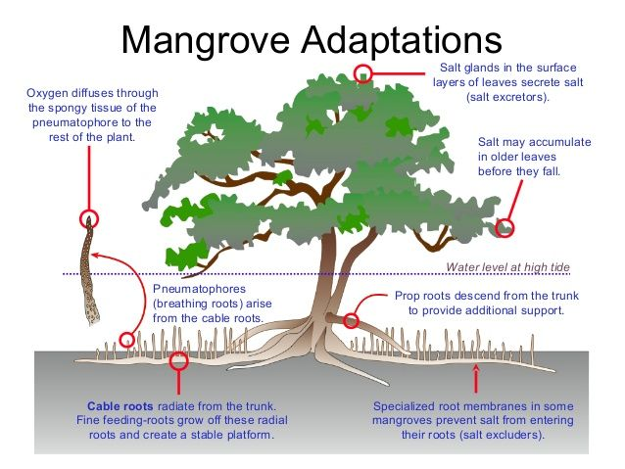

**To sum up….**

